LAB 05 DATABASE QUERYING - PART 3

Division, Nested Queries, and Advanced SQL Functions

1. LAB INFORMATION
Lab Name | Database Querying with Division, Nested Queries, and SQL Functions
Duration | 3 periods (150 minutes total = 3 × 50 minutes)
Software Required | Microsoft SQL Server 2019 or later  SQL Server Management Studio (SSMS)
Database | QLDeAnCongTy_Lab03P2 (Company Project Management Database)
Prerequisites | Completion of Lab 03 (Selection & Projection) and Lab 04 (Joins & Set Operations)

1.1 Learning Objectives
Upon completion of this lab exercise, students will be able to:
- Master the division operation in relational algebra and translate it into SQL queries using NOT EXISTS or double negation techniques for "for all" type questions.
- Write and optimize nested queries (subqueries) including correlated and non-correlated subqueries with proper use of IN, EXISTS, ALL, and ANY operators.
- Apply advanced SQL functions including string functions (CONCAT, SUBSTRING, UPPER, LOWER), date/time functions (YEAR, MONTH, DATEDIFF, DATEADD), and mathematical functions (ROUND, CEILING, FLOOR) to solve real-world data manipulation problems.
- Implement conditional logic using CASE expressions to create dynamic result sets and computed columns based on multiple conditions.
- Combine multiple query techniques (joins, subqueries, aggregation, and functions) to solve complex business intelligence queries.
- Analyze query performance and choose the most efficient approach between equivalent query formulations (e.g., JOIN vs. EXISTS vs. IN).

2. INSTRUCTIONS AND PRACTICAL CONTENT

2.1 Real-World Context
In modern database management systems, complex business questions often require advanced query techniques beyond simple selections and joins. For instance:
- Finding employees who work on ALL projects in a department (division operation)
- Identifying top performers whose salary exceeds their department average (correlated subquery)
- Generating formatted reports with calculated fields like age, years of service, and salary grades (functions and CASE)
- Determining employees eligible for bonuses based on multiple criteria (complex conditions)
This lab session focuses on these advanced SQL capabilities using a comprehensive company management database containing employees, departments, projects, and assignments. You will practice translating complex business requirements into efficient SQL queries.

2.2 Practical Tasks

Task A: Database Setup and Verification (15 minutes)
- Connect to SQL Server using SQL Server Management Studio (SSMS)
- Verify the QLDeAnCongTy_Lab03P2 database exists (created in Lab 04)
- If not created, execute the provided setup script: QLDeAnCongTy_Lab04_Setup.sql
- Review the database schema by examining all tables: NHANVIEN, PHONGBAN, DEAN, PHANCONG, THANNHAN, DIADIEM_PHG
- Run verification queries to confirm data integrity
- Take screenshots of table structures and sample data for your report
💡 Verification Query:
SELECT * FROM NHANVIEN;
SELECT * FROM DEAN;
SELECT * FROM PHANCONG;

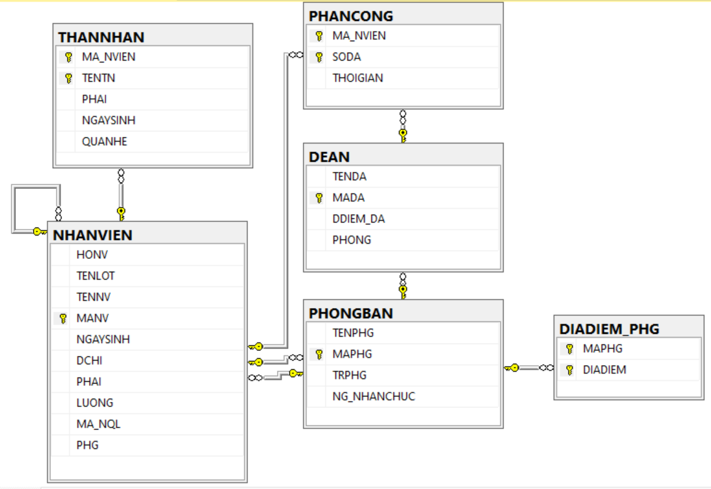

Task A: Challenge Problems (20 minutes)
Advanced exercises combining multiple concepts:

A1. Find employees who work on Project 1 OR Project 2, but NOT on both.
Hint: Use UNION and EXCEPT together. This is the XOR (exclusive OR) operation.
A2. List all employees along with their department name, supervisor name, and number of projects they work on.
Hint: Combine Cartesian Product, set operations, and aggregation.
A3. Create a report showing departments with their project count, including departments with zero projects.
Hint: Requires careful handling of departments without projects.
A4. Find employees whose salary is higher than the average salary of their department.
Hint: Combine Cartesian Product with subqueries and aggregation.

Task B: Division Operation and "For All" Queries (30 minutes)
The division operation answers questions like "Find X that are related to ALL Y". SQL does not have a direct DIVISION operator, so we use NOT EXISTS with double negation.
Exercise B1: Find employees who work on ALL projects managed by Department 5.
💡 Hint: Use NOT EXISTS with double negation. Structure: Find employees such that there does NOT exist a project in Dept 5 that the employee does NOT work on.
Expected: Employee IDs and names of those assigned to every Dept 5 project

Exercise B2: List employees who have worked on ALL projects (regardless of department).
💡 Hint: Compare total project count with employee's project count, or use NOT EXISTS.
Expected: Very few or no employees (depending on data)

Exercise B3: Find departments where ALL employees earn more than 30,000.
💡 Hint: Use NOT EXISTS: Find departments where there does NOT exist an employee earning ≤ 30,000.
Expected: Department codes and names meeting the criteria

Exercise B4: Identify employees who have dependents of ALL relationship types present in the database.
💡 Hint: First find all distinct relationship types, then use division logic.
Expected: Employees with diverse dependent relationships

Exercise B5: Find projects that have team members from ALL departments.
💡 Hint: Division: Projects related to all departments via employee assignments.
Expected: Project codes and names with cross-departmental teams

Task C: Nested Queries and Subqueries (35 minutes)
Subqueries allow you to use the result of one query inside another. They can be correlated (referencing outer query) or non-correlated (independent).

Exercise C1: Find employees whose salary is higher than the average salary of their own department.
💡 Hint: Use correlated subquery. For each employee, compare their salary with AVG(LUONG) of their department.
Expected: High performers within each department

Exercise C2: List projects that have more assigned employees than the average number of employees per project.
💡 Hint: Non-correlated subquery to find average, then filter projects.
Expected: Popular projects with large teams

Exercise C3: Find employees who work on at least one project in a different city than their department location.
💡 Hint: Use EXISTS with subquery joining multiple tables.
Expected: Employees with cross-location assignments

Exercise C4: Identify departments where the manager's salary is lower than at least one employee in that department.
💡 Hint: Use ANY operator with subquery.
Expected: Departments with potential salary inconsistencies

Exercise C5: Find the employee(s) with the second-highest salary in the company.
💡 Hint: Use MAX with WHERE LUONG < (SELECT MAX(LUONG) ...)
Expected: Employee(s) ranked #2 by salary

Exercise C6: List employees who have more dependents than their direct supervisor.
💡 Hint: Correlated subquery comparing dependent counts.
Expected: Employees with larger families than their managers

Exercise C7: Find projects that have NO employees from Department 1 working on them.
💡 Hint: Use NOT EXISTS or NOT IN with subquery.
Expected: Projects without Dept 1 participation

Task D: Advanced SQL Functions (35 minutes)
SQL Server provides powerful built-in functions for string manipulation, date/time calculations, and mathematical operations.

Exercise D1: Display employee full names in uppercase format: "LAST, FIRST MIDDLE".
💡 Hint: Use UPPER(), CONCAT() or + operator.
Expected: Formatted names like "NGUYEN, TUNG THANH"

Exercise D2: Calculate each employee's age and years of service (from NG_NHANCHUC for managers).
💡 Hint: Use DATEDIFF(YEAR, date1, GETDATE()) for calculations.
Expected: Columns showing Age and YearsOfService

Exercise D3: Extract the domain name from employee addresses (e.g., "TP.HCM" from full address).
💡 Hint: Use SUBSTRING() or CHARINDEX() to find and extract city names.
Expected: City/province names extracted from addresses
select DIACHI, SUBSTRING(diachi, len(diachi)- CHARINDEX(',',REVERSE(DIACHI))+2,CHARINDEX(',', REVERSE(DIACHI)))
from NHANVIEN
Exercise D4: Calculate each project's total cost assuming each hour costs 500,000 VND.
💡 Hint: SUM(THOIGIAN) * 500000, use FORMAT() for currency display.
Expected: Project costs formatted as Vietnamese currency

Exercise D5: Find employees whose birthday month is the current month.
💡 Hint: Use MONTH(NGAYSINH) = MONTH(GETDATE())
Expected: Employees with birthdays this month

Exercise D6: Round all employee salaries to the nearest thousand and display percentage above minimum wage (25,000).
💡 Hint: Use ROUND(), CEILING(), FLOOR() and arithmetic operations.
Expected: Rounded salaries and percentage calculations

Exercise D7: Generate email addresses for all employees using format: firstname.lastname@company.vn (lowercase, no Vietnamese characters).
💡 Hint: Use LOWER(), CONCAT(), and consider Vietnamese character replacement.
Expected: Generated email addresses

Task E: Conditional Logic with CASE Expressions (25 minutes)
CASE expressions enable conditional logic within SQL queries, similar to IF-THEN-ELSE in programming.

Exercise E1: Categorize employees into salary grades: "Entry" (<30K), "Mid" (30-40K), "Senior" (40-50K), "Executive" (>50K).
💡 Hint: Use CASE WHEN with salary ranges.
Expected: Employee names with assigned salary grades

Exercise E2: Display project workload status: "Underutilized" (<20 total hours), "Normal" (20-50), "Heavy" (>50).
💡 Hint: Use CASE with SUM(THOIGIAN) and GROUP BY.
Expected: Projects with workload status labels

Exercise E3: Create a seniority report showing retirement eligibility: "Eligible" (age ≥60 for men, ≥55 for women) or "Not Eligible".
💡 Hint: Use nested CASE considering both age and gender.
Expected: Retirement eligibility status for each employee

Exercise E4: Calculate employee bonuses: 15% for those with >3 dependents, 10% for 1-3 dependents, 5% for no dependents.
💡 Hint: Use CASE with LEFT JOIN and COUNT of dependents.
Expected: Employee names with calculated bonus amounts

Exercise E5: Classify projects by location: "Metropolitan" (TP.HCM, Hà Nội), "Coastal" (Nha Trang, Vũng Tàu), "Other".
💡 Hint: Use CASE with IN operator for multiple values.
Expected: Projects with location classifications

Exercise E6: Generate a performance summary: Show if employee hours exceed department average ("Above Average") or not.
💡 Hint: Combine CASE with correlated subquery for department average.
Expected: Performance comparison labels for each employee

Task F: Comprehensive Challenge Problems (20 minutes)
These advanced exercises combine multiple concepts from all sections. Work independently before seeking help.
Exercise F1: Create a comprehensive employee performance report including: full name, department, age, years of service, number of projects, total hours worked, average hours per project, salary grade, and performance rating (based on hours vs department average).
💡 Hint: Combine joins, subqueries, aggregate functions, date functions, and CASE.
Expected: Multi-column analytical report

Exercise F2: Find "universal employees" who work on ALL projects in their department AND have dependents of at least 2 different relationship types.
💡 Hint: Combine division operation with GROUP BY HAVING on dependents.
Expected: Very selective query returning only exceptional employees

Exercise F3: Generate a department comparison report showing: department name, number of employees, total projects, average employee salary, highest paid employee name, and budget utilization (total project hours * 500,000).
💡 Hint: Use window functions or multiple subqueries with GROUP BY.
Expected: Executive summary table for all departments

Exercise F4: Identify potential project manager candidates: employees who (1) work on at least 3 projects, (2) have salary in top 25% of their department, (3) have at least 2 dependents (showing stability), and (4) are between 30-50 years old.
💡 Hint: Multiple conditions using subqueries, CASE, and complex WHERE clauses.
Expected: Qualified candidates with supporting metrics

2.3 Tools and Software
- SQL Server Management Studio (SSMS) 2019 or later
- Microsoft SQL Server 2019 or later
- Text editor (Notepad++, Visual Studio Code) for documentation
- Screenshot tool (Snipping Tool, Windows Snip & Sketch) for capturing results
- Microsoft Word or compatible word processor for report submission

3. SUBMISSION GUIDELINES
File Format: Microsoft Word (.docx)
File Name: Lab05_StudentID_FullName.docx
Example: Lab05_2211012345_NguyenVanA.docx
Submission Method: Upload to Moodle LMS before deadline
Deadline: End of lab session (before leaving the computer lab)

